Starting with Mach 4

and ICNC 2.X

Before you begin, it's crucial to note that any Mach 4 build prior to version 5103 is not compatible with Soprolec Products, and ICNC2 cards need firmware version V5.38 CNC or later.

Table of contents
I – Plugin Setup 3
1 – Copy the following files: 3
2 – Uncheck the simulator device : 4
3 – Enable the Soprolec ICNC2 Plugin: 5
4 – Selecting the motion controller: 6
II – Configuration Example 7
1 – Defaults: 7
2 – Motors: 8
3 – Axis Mapping: 9
4 – Homing/Soft Limits : 10
5 – Input Signals : 11
6 – Output Signals : 11
7 – Analog Inputs : 12
III – Plugin and ICNC2 parameters 13
1 – Milling: 14
2 – Plasma: 14
IV–Plasma procedure and THC activation via G-code 15
V – Plasma cutting parameters 16
VI – Plasma Complete profile Soprolec 18
VII – Restriction of our plugin 18
1 – Probe : 18
2 – Homing : 18

I – Plugin Setup

1 – Copy the following files:

ICNC2Plugin4.m4pw, ICNC2_VS.dll, and ICNC2Plugin4.sig to the Mach 4 installation directory. Typically, Mach 4 is installed on the local disk C in a folder named 'Mach4Hobby' or 'Mach4Industrial.' You'll then paste these files into the 'plugins' folder within the Mach 4 directory.

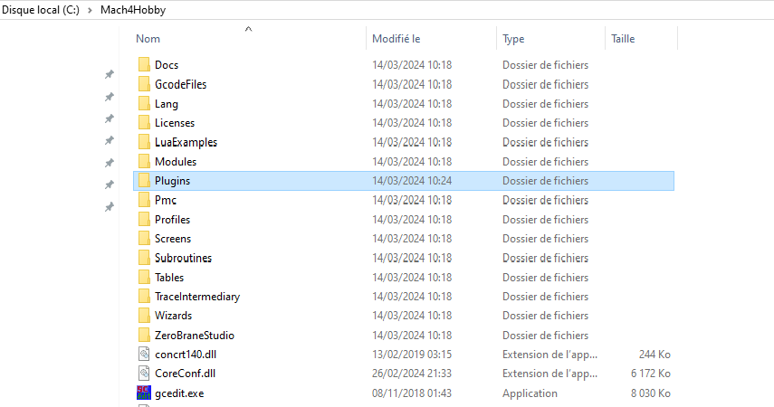

2 – Uncheck the simulator device :

Navigate to Menu -> Configure -> Select Motion Dev, then deselect the simulation device to prepare for adding our motion controller in the next step.

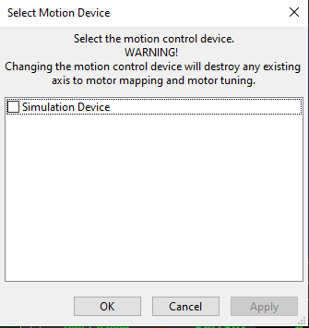

3 – Enable the Soprolec ICNC2 Plugin:
- Navigate to Menu -> Configure -> Control -> Plugins tab.
- Ensure that the “Soprolec – ICNC2” plugin is enabled with a green check-mark. If not, click on it to enable it. Remember, you'll need to restart Mach4 if you've made changes to enable it.
- Additionally, enable the following plugins:
- Keyboard Inputs (allows keyboard jogging)
- Core – Newfangled Solutions
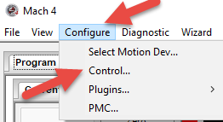

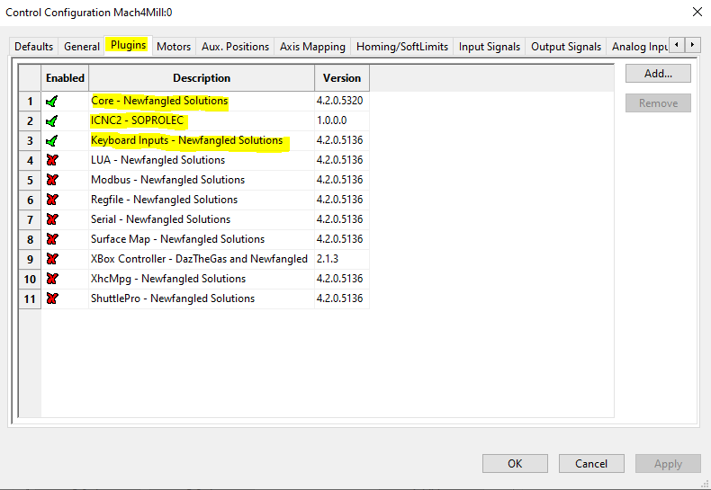

4 – Selecting the motion controller:
After restarting Mach 4, follow these steps:
-Go to Menu -> Configure -> Select Motion Dev.
-Check ICNC2-SOPROLEC from the list of available motion controllers.
-Press "OK" to confirm your selection.

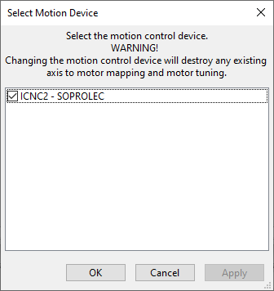

After this step, Mach 4 will be communicating with your ICNC2.X. You can verify this by checking the history button located at the lower left corner of the screen to visualize the received messages.

II – Configuration Example
The following steps outline the configuration process for your milling machine: we will configure our machine as a 3-axis milling machine with 3 homing sensors (NC), one for each axis. This machine does not have max limit sensors, so we will configure software soft limits and manage the emergency stop .

1 – Defaults:
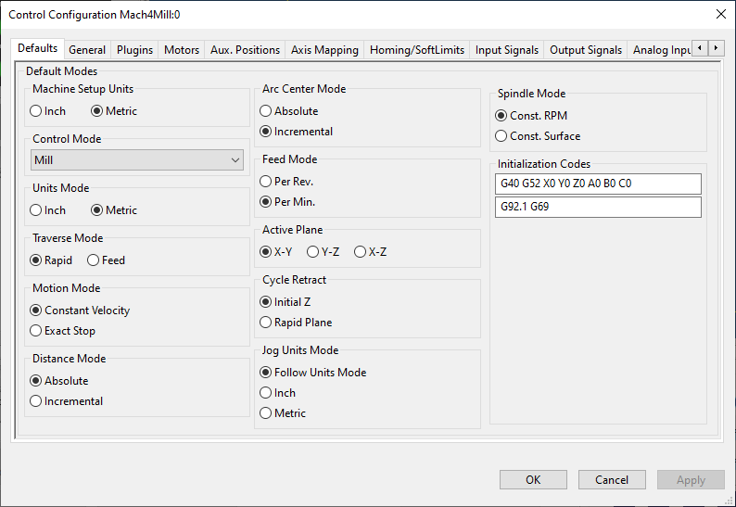
As you can observe, the units have been configured in the metric system (mm).

2 – Motors:
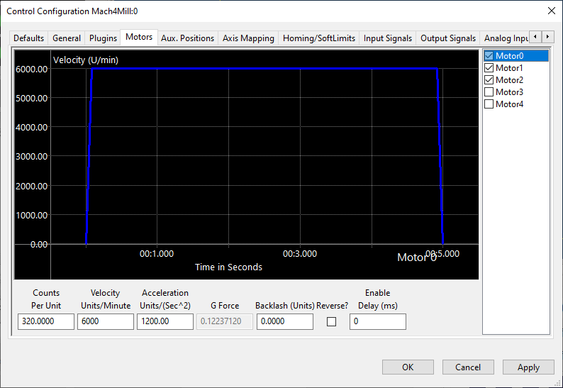
In this section, we will configure the motors. It's crucial to differentiate each motor from its corresponding axis. For instance, while a motor can only be configured for one axis, an axis can accommodate multiple motors.
First, we need to identify and check the first three motors since we are configuring a 3-axis machine. Then, for each motor, proceed to configuration. Begin by setting the counts per unit. Since we've configured the system in the metric system, this corresponds to pulses per mm. In my case, it's 320 because my drivers are set to 1600 pulses per rotation, and the screw has a pitch of 5mm per step, resulting in 1600/5 = 320 pulses per mm. Next, specify the velocity and acceleration parameters. Repeat this process for all three axes.

3 – Axis Mapping:
In this section, we will enable the axes and assign motors to them. (Don't forget, after completing this step, return to the Motors tab and reverse the motor assignment for the Z-axis if applicable.)
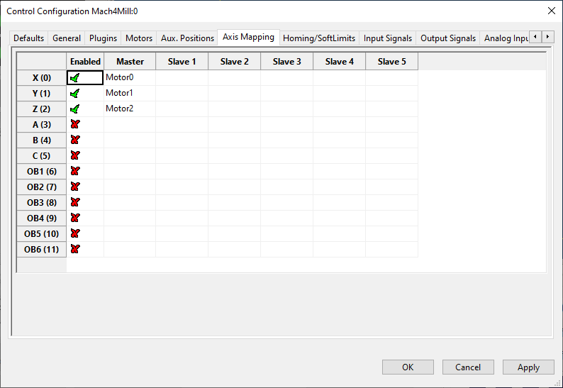

4 – Homing/Soft Limits :
On this tab, it is essential to adjust your machine dimensions under the parameter soft limits, both plus and minus. Additionally, you can customize the homing direction for each axis and arrange the order of homing for your axes.
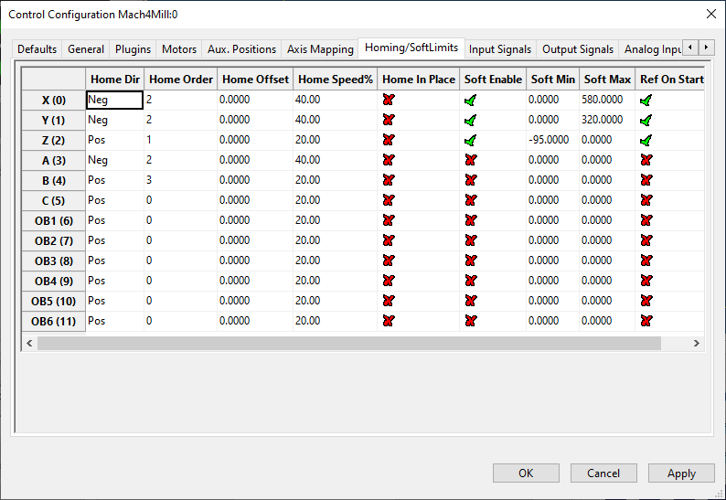

5 – Input Signals :
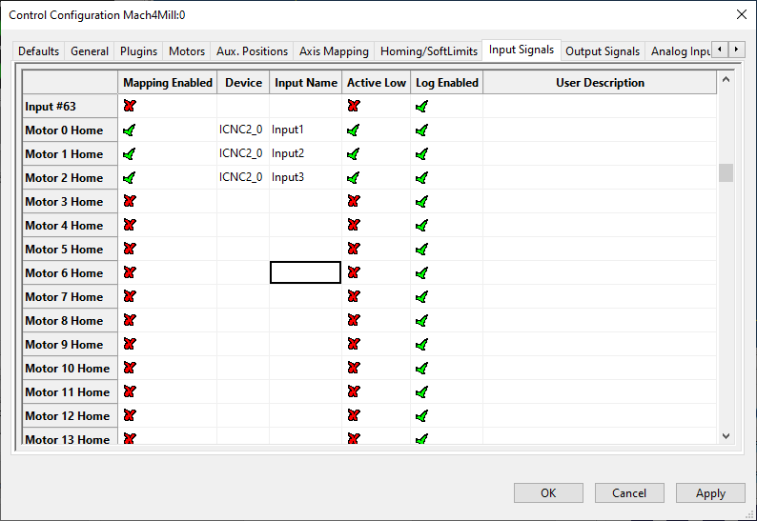
Among the crucial inputs in our setup are the three homing sensors and our emergency stop (e-stop) input. The e-stop input is a simulated input generated by our plugin, mirroring the Enable state of your ICNC2.X. This input operates as an active high input.

6 – Output Signals :
In our example, we will configure one enable output for our drivers and another for our spindle.

7 – Analog Inputs :
« Numerator » is the maximum voltage value admissible by the input.
« Denominator » is the resolution of the used Digital to Analog converter (1024 stands for 10 bits).
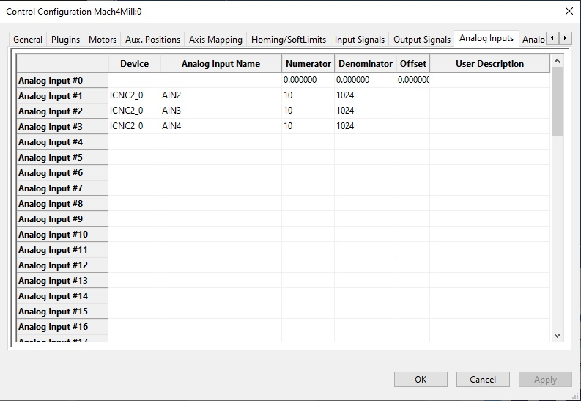

III – Plugin and ICNC2 parameters

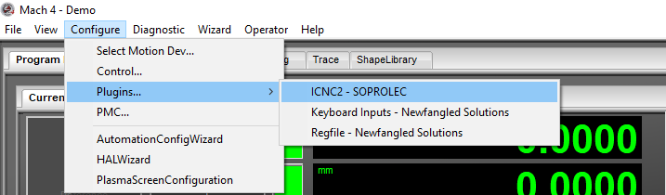
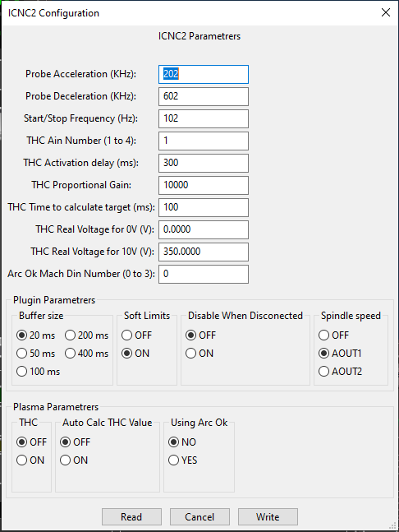

1 – Milling:
If you wish to use Mach4 to command a milling machine (without a plasma torch), the only parameters that matter for you are:
Probe Acceleration: Acceleration while performing a probe.
Probe Deceleration: This value must be high so the axis stops immediately when the input changes state.
Start/Stop Frequency: The default value is 100 Hz.
Buffer Size: This parameter is crucial as it defines the buffer size of your ICNC2. To find the perfect value for your setup, start with the lowest value (20 ms). After saving the parameter by clicking on the write button, jog one of your axes at high speed. If the jogging is smooth without any blockage in the middle of the movement, you have chosen the perfect value. If not, try a larger value. Note: if the parameter is too large, it will reduce your machine's reactivity during jogging movements.
Soft Limits: When this parameter is on, your machine will respect the programmed machine bounds at every start (you will not be able to move beyond the programmed limits).
Disable When Disconnected: If this parameter is on and your ICNC2 USB connection gets disconnected, it will automatically disable Mach4. We recommend enabling this function.
Spindle Speed: This parameter is by default OFF. It is only useful if your spindle speed is commanded by an analog output on your ICNC2. If this is the case, you will need to choose an analog output. Then, the actual spindle speed will be scaled between 0 and 10 V based on your maximum programmed RPM in the Mach4 configuration.
THC: This parameter should always be OFF if your machine is not a plasma cutting table.

2 – Plasma:
If you wish to use Mach4 to operate a plasma cutting machine, all the parameters mentioned above are useful, along with the THC parameters:

THC Ain Number: This is the number of the THC analog input. It needs to be between 1 and 4. If this input is not valid, the THC will not start.
THC Activation Delay: Delay that occurs after the activation of the THC via the macro script. If you use auto-calculate THC Value, then the value of this parameter needs to be 0.
THC Proportional Gain: This parameter determines the reactivity of THC movements.
THC Time to Calculate Target: This value is only useful when the auto-calculate THC Value is ON. It determines the time of inactivity of the THC at the beginning of the cutting, then calculates the best THC target for your material based on the cutting height. The calculated value can be visualized in the THC Diagnostics tab under Target voltage.
THC Real Voltage For 0V: The real voltage of the generator when the analog input is at 0V.
THC Real Voltage For 10V: The real voltage of the generator when the analog input is at 10V.

Arc OK DIN Number: The Mach4 digital input number for your generator's digital output arc OK.

THC: This parameter must be enabled for plasma cutting.
Auto Calc THC Value: When enabled, this parameter automatically calculates your THC cutting voltage based on your cutting height. If disabled, you will need to manually input this value as explained below in the V-Plasma cutting parameters.
Using Arc OK: This parameter allows you to choose whether to wait for the Arc OK signal from your generator or to use a delay after turning on your torch.

IV–Plasma procedure and THC activation via G-code

Firstly, ensure that in your G-code, the Z-axis isn't commanded during the time the torch is activated until it's turned off. Under no circumstances should your G-code include any Z-axis movement during the cutting phase.

To perform the plasma cutting procedure, including tasks like probing, height adjustment, waiting for an OK signal, delay settings, pierce height, pierce delay, and cutting height, you'll need to use M47. This M-code triggers a macro script that utilizes parameters specified in the screen (probe offset, delay times, heights...) to generate corresponding G-code instructions. Note that if THC (Torch Height Control) is enabled in the plugin parameters, this M-code will activate the THC.

At the end of the cutting process, to turn off the torch, you'll use the standard M5 command. This will deactivate the THC if it's enabled and switch off the torch. If you intend to include any Z-axis movement, you must insert a G4 P500 command into your G-code, creating a brief delay to ensure the THC is fully deactivated. Following this, you can incorporate your Z-axis movement G-code lines.

V – Plasma cutting parameters
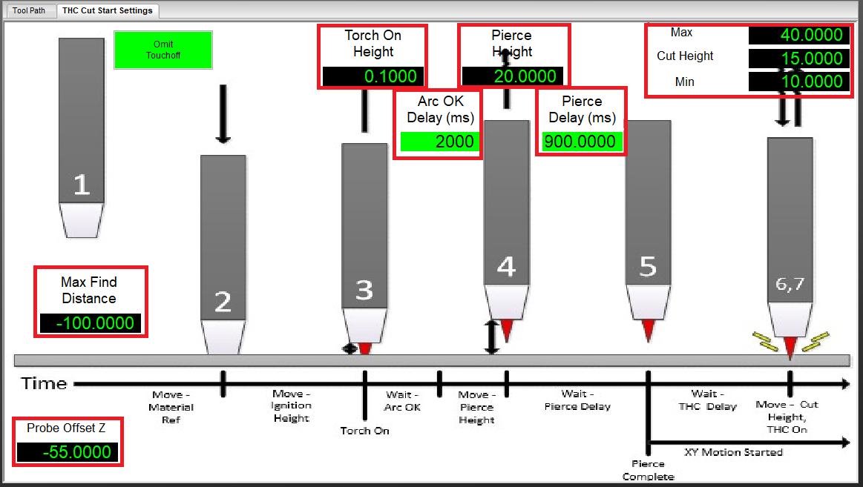
This diagram represents the plasma cutting procedure, outlining the necessary steps before starting a plasma cut. All parameters highlighted in red are crucial for this operation.
Procedure explanation:
1. The torch will first probe to find the sheet's position.
2. Once probing ends, it will adjust according to the offset position to account for deceleration delay.
3. The torch will then move to the height required to turn it on.
4. After activation, it will wait for an "arc OK" signal (if the "Using arc OK" parameter is enabled in the plugin settings).
5. Following this, the torch will reposition to the pierce height and wait for a given delay.
6. Finally, it will move to the cutting height and start the cut. on the THC

Max Find Distance: The maximum distance the probe can travel. If this distance is reached and the probe input does not detect the torch, a probe error will be generated, stopping the probing process.
Probe Offset Z: The movement after probing to compensate for the deceleration delay, relative to the probe position.
Torch On Height: The height at which the torch will be turned on, relative to the height after the probe offset.
Arc OK Delay: The delay, in milliseconds, after receiving the "arc OK" signal.
Pierce Height: The height at which the material will be pierced, relative to the height after the probe offset.
Pierce Delay: The delay, in milliseconds, for piercing the material.
Cut Height: The height at which the material will be cut, relative to the height after the probe offset.
Max: The maximum height for cutting the material with the THC, relative to the height after the probe offset.
Min: The minimum height for cutting the material with the THC, relative to the height after the probe offset.
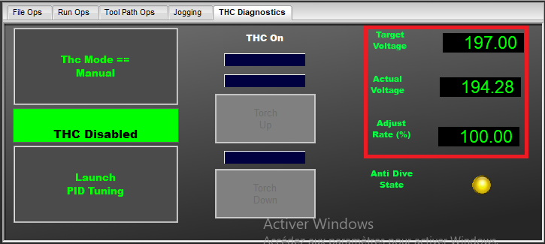
Target Voltage: This is the THC (Torch Height Control) target voltage. If the "Auto Calculate THC Target" parameter is enabled, this target voltage will be calculated at the beginning of the cut based on the cutting height. If this parameter is disabled, you will need to input the target voltage manually.
Actual Voltage: This is the actual voltage measured on the analog input, scaled appropriately.
Adjust Rate: This is the THC adjustment speed, expressed as a percentage of the maximum speed of the Z-axis.

VI – Plasma Complete profile Soprolec

To simplify your machine configuration, you can download the complete plasma profile from our website. This includes a plasma screen and the full configuration for the machine. In this zip file, you will find folders corresponding to those in the Mach4 installation. You will need to copy every file from each folder and paste it into the corresponding folder in your Mach4 installation directory.

VII – Restriction of our plugin

1 – Probe :
-Only the input probe, designated as G31, should be used with our plugin. Probe Inputs labeled as probe 1, 2, or 3 are not compatible. Specifically, using G31,1 or G31,2 will yield the same result as G31 alone, focusing solely on the input probe.
-The G-code line featuring G31 for probing can only specify one axis at a time. If multiple axes are mentioned, only the axis associated with the lowest motor number will be probed.
-Probing is only effective on axes that are not linked to slave axes. If a linked axis is probed, it will result in an error message, and the probing action will not take effect.

2 – Homing :
-If your homing input is not assigned, the homing process will not take effect. If you initiate homing for an axis that has a slave axis, both homings will be launched simultaneously.

